National Geographic: Migration Name: _________________________________ Per. _______
COMPLETE SENTENCES!
 | Jews to Palestine | African Americans | Afghans | Vietnamese | Romani
- When did the migration occur?
- Where did it start and end?
- What were the reasons for the migration? Were there push factors or pull factors?

- What challenges did humans face on the migration?

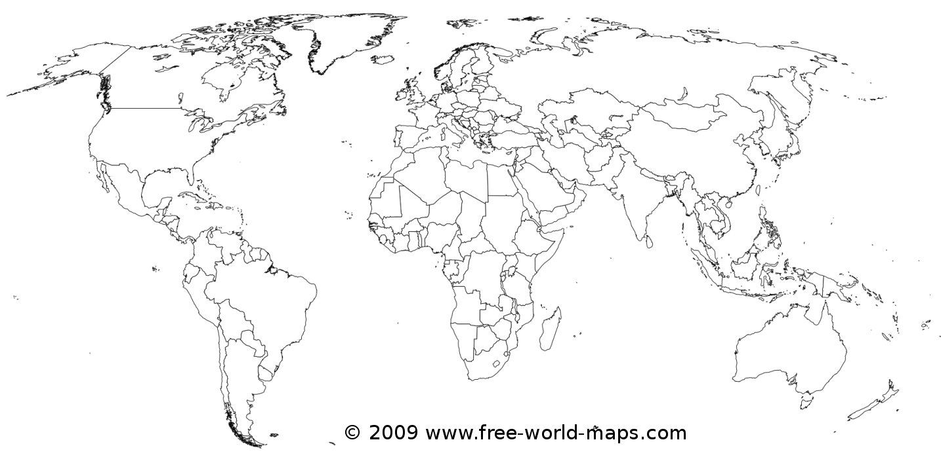
Key:
Jews to Palestine: African Americans: Afghans: Vietnamese: Romani:

