The Culture Project
Find an example of folk culture and its equivalent in popular culture within a single country! Do some research about it! [30 pts]

Ideas:
- Country of Origin
- Name and creator
- Sample (youtube url for music and dance, a printed pic for everything else)
- 5 Paragraph essay
  - Intro
  - Use a body paragraph explaining the backgrounds of each
  - Use the third body paragraph to compare them
  - Conclusion
- TYPED (12 pt font, Times New Roman, double spaced)
- Works Cited Page with 4 REPUTABLE SOURCES
  - Use Easybib.com, Bibme.org

- Music
- Art
- Dance
- Fashion
- Sport
- Architecture
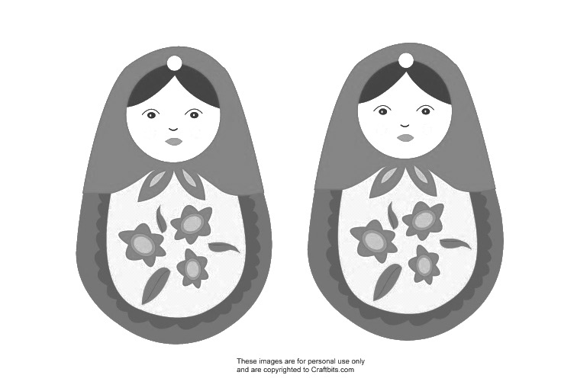

The Culture Project
Find an example of folk culture and its equivalent in popular culture within a single country! Do some research about it! [30 pts]
- Country of Origin
- Name and creator
- Sample (youtube url for music and dance, a printed pic for everything else)
- 5 Paragraph essay
  - Intro
  - Use a body paragraph explaining the backgrounds of each
  - Use the third body paragraph to compare them
  - Conclusion
- TYPED (12 pt font, Times New Roman, double spaced)
- Works Cited Page with 4 REPUTABLE SOURCES
  - Use Easybib.com, Bibme.org

Ideas:

- Music
- Art
- Dance
- Fashion
- Sport
- Architecture

