1) The best example of a state among the following is
A) an island with a long history of self-rule and a homogeneous ethnic identity, although the island has been under the control of a colonial power for the last 30 years.
B) a group of islands inhabited by a homogeneous ethnicity, although the westernmost islands pertain to the territory of one country whereas the easternmost islands pertain to another country.
C) a mountainous region inhabited by heterogeneous ethnicities and divided up administratively among various independent countries.
D) a mountainous region inhabited by heterogeneous ethnicities which share responsibility for maintaining an independent government and a standing army.
E) a mountainous region inhabited by a mixture of peoples but recently colonized by a European nation-state.

2) Examples of major nation-states are
A) Germany and Denmark.
B) Australia and New Zealand.
C) Russia and the United States.
D) Mexico and Russia.
E) Mexico and Germany.

3) The conflict over the Aozou Strip involves
A) centripetal forces acting in the absence of any centrifugal forces.
B) a disputed border and Egypt's claims of sovereignty over the zone.
C) a disagreement regarding suffrage and a disputed border.
D) a disputed border and Libya's claims of sovereignty over the zone.
E) Aozou attempts to join the United Nations as a sovereign nation-state.

4) The boundary between Argentina and Chile is an example of a
A) prorupted boundary.
B) geometric boundary.
C) physical boundary.
D) cultural frontier.
E) perforated frontier.

5) A Southeast Asian country with a partly elongated or prorupted shape is
A) Pakistan.
B) China.
C) Cambodia.
D) Thailand.
E) Indonesia.

6) A South American country with an elongated shape is
A) Bolivia.
B) Colombia.
C) Brazil.
D) Chile.
E) Ecuador

7) An increasing number of states have adopted a federal form of government primarily to
A) grant different ethnicities or nationalities more effective representation.
B) encourage the breakup of the superpower alliances.
C) govern compact states more effectively.
D) deploy scarce resources efficiently.
E) accommodate rightwing political parties and their demands for more representation in national elections.

8) The boundary between the two Germanys was determined by
A) Cold War alliances and rivalries after World War II.
B) membership in the United Nations, along with nationalistic issues.
C) the growth of fascism in Europe.
D) the changing physical boundaries of Europe's major rivers and coastlines.
E) cultural issues involving shifting language patterns in Europe.

9) Which of the following is true about both China and Taiwan?
A) Neither one is a member of the United Nations.
B) Both consider Taiwan to be the sovereign property of the communist government in Beijing.
C) Both now hold seats in the United Nations.
D) Neither was once ruled by the Nationalists, although both have official relationships with the United States.
E) Both were once ruled by the Nationalists, and both have official relationships with the United States.

For the rest of the questions, refer to the maps below.

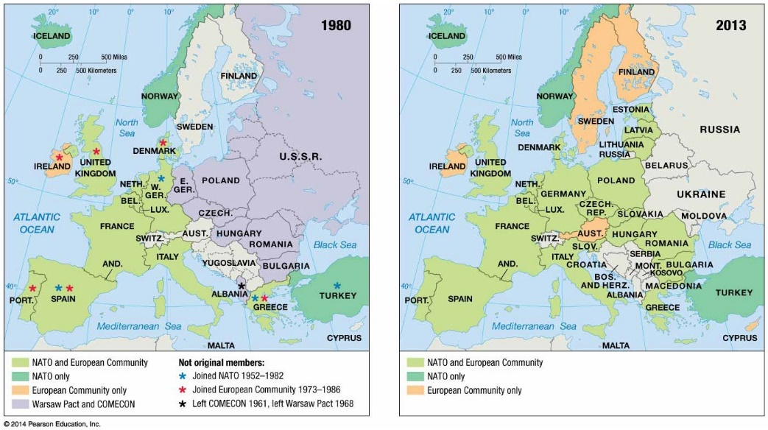

10) As indicated on the maps of economic and political alliances, in the late 20th century Austria
A) was a member of NATO and the European Community.
B) was a member of NATO but not the European Community.
C) was a member of the European Community but not NATO.
D) remained nonaligned with either NATO or the Warsaw Pact.
E) was a member of the Warsaw Pact and COMECON.

11) As indicated on the maps of economic and political alliances, in 1980 Sweden
A) was a member of NATO and the European Community.
B) was a member of NATO but not the European Community.
C) was a member of the European Community but not NATO.
D) remained nonaligned with either NATO or the Warsaw Pact.
E) was a member of the Warsaw Pact and COMECON.

12) As indicated on the maps of economic and political alliances, in 1980 Belgium
A) was a member of NATO and the European Community.
B) was a member of NATO but not the European Community.
C) was a member of the European Community but not NATO.
D) remained nonaligned with either NATO or the Warsaw Pact.
E) was a member of the Warsaw Pact and COMECON.

13) As indicated on the maps of economic and political alliances, in 1980 Ireland
A) was a member of NATO and the European Community.
B) was a member of NATO but not the European Community.
C) was a member of the European Community but not NATO.
D) remained nonaligned with either NATO or the Warsaw Pact.
E) was a member of the Warsaw Pact and COMECON.

14) As indicated on the maps of economic and political alliances, in 1980 Bulgaria
A) was a member of NATO and the European Community.
B) was a member of NATO but not the European Community.
C) was a member of the European Community but not NATO.
D) remained nonaligned with either NATO or the Warsaw Pact.
E) was a member of the Warsaw Pact and COMECON.

15) As indicated on the maps of economic and political alliances, in 1980 Hungary
A) was a member of NATO and the European Community.
B) was a member of NATO but not the European Community.
C) was a member of the European Community but not NATO.
D) remained nonaligned with either NATO or the Warsaw Pact.
E) was a member of the Warsaw Pact and COMECON.

