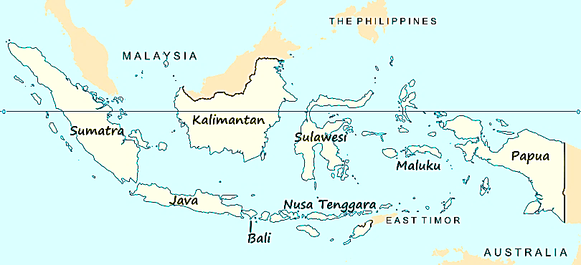
Read through this academic article about Indonesian folk culture. Highlight 5 quotes that represent the main ideas of this article or stand out to you. Write 1 sentence per quote explaining why you choose that quote.
Due October 17.
Relationships of Musical and Cultural Contrasts in Java and Bali
By Fredric Lieberman
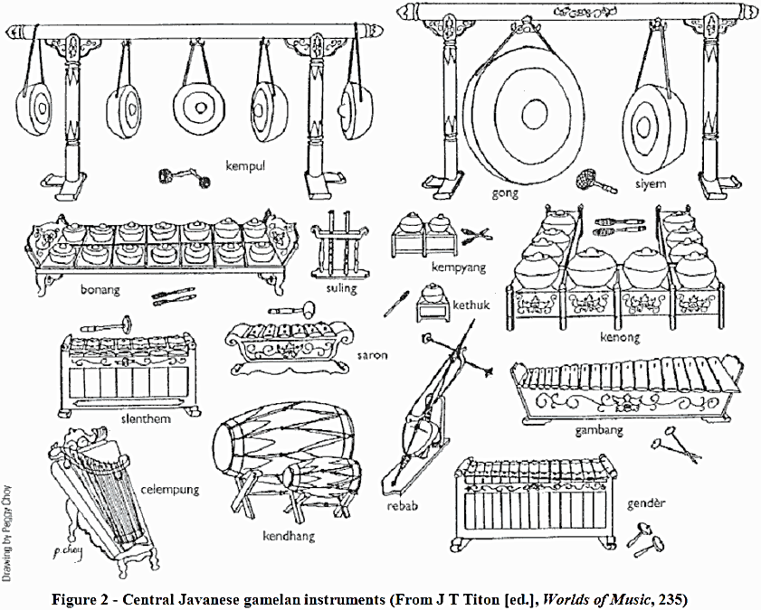
Contrasts of Music Style
Perhaps the best summary of the contrasts is that of McPhee:
Javanese gamelans have an incredibly soft, legato, velvet sound; the hammers and mallets that are used to strike the metallophones and gongs are padded so thickly as to eliminate all shock. Tempos are slow and stately, and there is little change in dynamics; the prevailing mood is one of untroubled calm and mystic serenity. Balinese music, on the other hand, is vigorous, rhythmic, explosive in quality; the gamelans sound bright and percussive; hard hammers of wood or horn are used for many instruments, and the thin clash of cymbals underlies every tone; only the great gongs are gently struck. While the classic calm of Javanese music and dance is never disturbed, music and dance in Bali is turbulent and dramatic, filled with contrast and bold effects. Javanese musicians find the music of Bali barbaric. Balinese complain that the music of Java "sends them to sleep." (1949:25l )

Patterns of Cultural Variation
Wayang, the puppet theater, is a major element in both Javanese and Balinese society, important both as an integral part of many rituals and as a repository of tradition with overtones of ancestor-worship. In Bali, wayang is performed exclusively with flat leather puppets (kulit). Javanese variants exist with puppets of flat wood (klitik), round wood (golek), and with no puppets at all, in an extremely rare moribund tradition (beber) in which the scenes are painted on a long scroll which unrolls as the story is recited. The major Javanese form, however, is wayang kulit. Wayang is accompanied by a full gamelan, in Bali by four gender. The literature is largely drawn from the Mahabharata and the Ramayana, less popular being the indigenous culture-hero epics. In addition on special occasions (in Bali only), the story of Tjalanarong is performed. Balinese puppets are more realistic than the Javanese, which have become highly stylized. In fact, the Balinese puppets closely resemble the figures carved in bas-relief on old Hindu temples of East Java (McPhee 1936:3). The Javanese wayang performance is more formal than that of Bali, lasting through the night, which is divided into three periods, each period having a corresponding type of action and musical mode. The Balinese wayang performance differs greatly in length and structure from night to night because it is ". . . determined by the dalang, according to wages, enthusiasm of the audience, or the wish of the person who has engaged him." (McPhee 1936:3)

It seems dear that one can contrast dance movement in Java and Bali with the same terms as were found applicable for music, because in both societies dance movement and music are in close cooperation. Hence Javanese dance movement is controlled, deliberate, refined; Balinese, dynamic, angular, intensely expressive. There is a greater richness of dance forms and styles in Bali; and particularly notable are those ritualistic dance dramas which involve Rangda, the witch and the great beast Barong. These are of major import in Bali but do not exist in Java. Rangda is the queen of witches (leyak), the personification of virulent evil, continually scheming to harm mankind. Barong is also a leader of demons, but of the kala, who are a mischievous and uncouth lot, but susceptible of propitiation. Thus Barong, having power over Rangda, is seen as a representative of "good" forces countering Rangda's "evil," and their ritual confrontation is a symbolic reenactment of the precarious balance of good and evil forces in this world. The continual ritual-dramatic defeat of Rangda is perhaps meant as sympathetic magic. In any event, it reinforces in the community conscience the sense of real need for the multitude of propitiatory rituals which characterize Balinese religious practice.
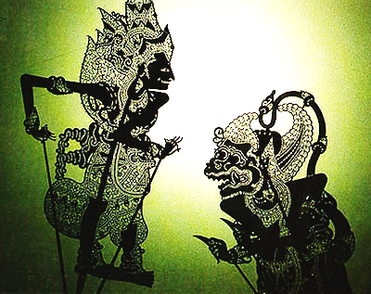
The masks used masked play genres in Java and Bali are compared by Wagner as follows: "Javanese art often displays a finesse, and at the same time a serene composure which . . . is elevated far above everything mundane. But the Balinese artist draws directly upon his own experience; his masks often represent changing human moods." (1959:204)

In Bali the social order is largely communal, stressing traditional law (adat) supervised by the entire adult male population of a community, a committee of the whole. This pattern encompasses other aspects of Balinese life, and there is thus a committee on rice paddies, a committee on ritual, etc. The social class structure superficially resembles that of traditional Hindu culture, with brahmanas, ksatriyas, vaisyas, and sudras. However, the sudras, or common people (about 95 per cent of the population), control their own affairs at the village level with little or no attempt at control by the hereditary nobility (ksatriya, vaisya). Balinese religion is an integration of Hindu-Buddhist and shamanist beliefs, characterized by a regular cycle of temple festivals featuring elaborate food-offerings and other ceremonies as needed for rites of passage, healing, or crisis situations. Music and dance play a major role in Balinese religion, as does trance. (See following discussion on trance.) Most temple business is conducted by a sudra lay-priest who doubles as temple janitor, while the learned brahmana priests are called upon only for occasional rites of major import, or nobility-sponsored ceremonies (e.g. consecrating a new house). Many of the finest dalangs are priests, but there is no prohibition against dalangs of other profession or caste. Persons of high caste receive the respect and courtesy of accepted social usage. These courtesies are dropped in the context of artistic activity (music or dance-drama), and in general the high castes would seem to have few prerogatives in Bali's peasant-dominated society.

Javanese society is tripartite, divided by the Javanese themselves into abangan (peasantry), santri (Islamic, usually merchants), and prijaji (nobility and cultural elite). Abangan religion is similar to Balinese religion, though not nearly so elaborate, stressing community and built around the communal offering of propitiation, the slametan feast. As in Balinese temple festivals. the slametan consists of the presentation (to the spirits) of specially-prepared ritual foods. Because the communal feeling does not spontaneously exist to any great extent in Java, slametan is typically given by private individuals rather than by villages or communities. The abangan who gives a slametan, therefore, will create an artificial community-by-proximity, inviting his immediate neighbors to the ritual feast, regardless of his normal social relationships with them: they are witnesses, not co-celebrants.

The santri stresses the unity of the Islamic community, and all attendant ritual trappings of Islamic law. The santri is not wholly isolated from the Hindu-Javanese tradition, however, as he acknowledges the (limited) import of the wayang, and admits the ancient gamelan sekati to the celebration of the holy week.

The prijaji element is the gentry of Java, today composed largely of white-collar workers and other educated professional people. Prijaji religion is an intellectualization of the basic elements of Hindu-Javanese tradition, giving elaborate symbolic and mystic interpretations to wayang, gamelan, etc. Certain elements of Islamic practice are also congenial to prijaji mysticism, such as fasting, which fits in nicely with the prijaji stress on meditation and abstinence as a means towards acquisition of personal spiritual power. The prijaji element remains the repository of Javanese culture, despite its confrontation with (and acceptance of) western values: "The current (1954) prijaji culture-hero is the Sultan of Djokjakarta, who, it is said, behaves exactly like a conservative, mystic, traditional king within his palace and like a progressive, modern, Dutch-educated political leader outside of it." (Geertz 1960:237)

A custom which may help to preserve the concept of class distinction (and which certainly serves to articulate it) in Java and Bali is that of varying levels of language. Courtesy demands that one speak with a language of refinement equal to that of the person one is addressing. Thus a servant will address his master in the elaborate high Javanese (or Balinese), and will be answered in the low tongue. Though this principle operates similarly in Java and Bali, it seems that there are more levels in Java, capable of expressing subtler distinctions of rank than possible in Bali. Also current is the lingua franca Indonesian, which is increasingly more common in large urbanized areas. The classical languages, sanskrit, and kawi, are mastered only by the elite prijaji in Java, who thus maintain a measure of control over the classical literature and other cultural elements. In Bali knowledge of kawi is also limited. When dranas are presented in kawi, they must receive a running translation by comic characters (usually servants). A similar but more limited situation is found in the Japanese no drama, in which the story is explained during the "intermission" by a kyogen (comic servant). In Bali the comic characters often tend to monopolize the stage; in Java, though favorites, they are more clearly secondary. Another language in Java is Arabic, used--but not necessarily understood--by the santri in chanting the prayers of the Islamic office.

Trance in Bali is a common phenomenon and an essential part of religion. Trance is believed to indicate possession by a spirit, and the entranced medium speaks with the spirit's voice, giving instructions for proper offerings or ceremonies, helping to heal or find lost objects. Entranced dancers are basic elements of several temple festivals, and dalangs giving particularly efficacious wayangs, may become entranced in the normal course of events. Trance, then, is a culturally valuable trait in Bali, and is an important shamanistic virtue, allowing communication with the spirits.

In Java, trance is the exception rather than the rule. In the djaranan, for instance, itinerant street-dancers become entranced while imitating a horse providing some entertainment value, but little or no cultural or religious significance. There is no Javanese counterpart to the Balinese entranced temple dancers such as the sanghyang. The abangan folk-healer (dukun) does not normally use trance, but rather has definite training in traditional healing practice. On rare occasions an untrained person may become possessed by a spirit (dukun tiban) and may exhibit strong healing powers for a limited time, but will eventually lose these powers permanently. Even rarer is the possessed dalang (dalang tiban). Thus in Java trance is not a culturally valuable trait, indicating a lack of stress on traditional shamanistic practice.

In the foregoing sections, several elements of Javanese and Balinese culture have been compared and contrasted, and a basic pattern of order or contrast may be seen. Balinese culture appears less sophisticated than Javanese, more folk-like, primitive, direct. Javanese culture, on the other hand, stresses refinement, subtlety, and indirection.

Factors Leading to Patterns of Cultural Variation
The indigenous cultures of Java and Bali were brought under influence from India in the early centuries A.D., and we have no historical records from periods preceding the advent of Indian influence. Java and Bali were joined by politics and political marriages under various Hindu-Buddhist dynasties up to the eleventh century. Later the Madjapahit dynasty in Java renewed control over Bali. Madjapahit in Java was beset by the influence of Islam, and perhaps in reaction to this intellectual foreign importation the prijaji developed their highly nationalistic brand of mysticism. Islam did not extend its influence to any appreciable extent in Bali, however, and with the fall of Madjapahit in the fifteenth century, the Madjapahit nobility moved en masse to Bali, bringing with them the traditions of Hindu-Buddhist culture. Certain elements of this tradition have been preserved in Bali. After Madjapahit, the cultures of Java and Bali, up to then more or less homogeneous, evolved along different lines. Western influence in Java dates from the seventeenth century; Bali, however, resisted complete Dutch control until early in the twentieth century. The Dutch in Java worked through the prijaji, thus reinforcing the power of the traditional government. In Bali the nobility gradually lost its power and influence.

In Java the advent of Islam resulted in the formation of a tripartite society, Dutch control strengthening the leadership prerogatives of the traditional nobility. Thus in Java cultural patterns originating with the nobility filtered down to the peasantry and mixed with and influenced abangan values, the peasantry attempting to emulate the gentry, considering elite cultural values the national ideal, the quintessence of Javanism. This is the reason for the air of refinement permeating Javanese culture.

In Bali the imported nobility was less important; the nobleman was a power to be tolerated, not an ideal figure to be emulated. The basic cultural values originated with the community, hence their more popular character.

The Relationships Between Cultural Patterns and Music Styles
The nature of the contrasting gentry-peasantry relationships in Java and Bali would seem to explain the differences of musical style. ". . . traditionally, the musicians in service of the Royal Courts of Central Java were palace servants. The music they composed and performed… enjoyed the highest evaluation not only by the elite for whom they performed, but also by all levels of society who emulated the same repertoire through the communal efforts of the village musicians performing on instruments of relatively poor quality." (Hood 1963a:3) By contrast, "one of the most famous orchestras in Bali is to be found in the remote mountain village of Selat, and the finest dancers of legong were in Saba, an unimportant little village hidden among the rice fields . . . The Balinese did not permit the centralization of the artistic knowledge in a special intellectual class.'' (Covarrubias 1937:160 62)

The factors of preservation and change are present in Balinese and Javanese music history. The rejong, for instance, evolved from the shared prototype (known from East Java temple reliefs) in different directions in Java toward the improvisatory bonang, in Bali toward the volatile four-man rejong. Wayang puppets were probably preserved better in Bali because of the realism and direct appeal of the traditional figures. In Java the urge towards refinement, and perhaps the influence of Islam, contributed to the evolution of more abstract and stylized figures. The reverse situation appears in relation to traditional tunes, which have probably been preserved better in the Royal Court manuscripts of Java than in the mercurial oral tradition of Bali.

Thus we see that differences of musical style in Java and Bali may be attributed to and justified by factors of preservation and change acting through time in the context of cultural patterns congenial to the individual spirits of each island society.

Legato: in a smooth, flowing manner
Metallophone: any musical instrument consisting of tuned metal bars which are struck to make sound, usually with a mallet.
Gamelan: A traditional musical group of Indonesia, including many bronze percussion instruments
Turbulent: characterized by conflict, disorder, or confusion. Not controlled or calm.
Repository: a place where things are or may be stored.
Bas-Relief: a sculpture, carving or molding that has less depth to the faces and figures than they actually have.
Virulent: bitterly hostile, or extremely severe or harmful in its effects
Finesse: intricate or refined delicacy
Shamanist: Shamanism is a religion practiced by indigenous people that beliefs in gods, demons, and ancestral spirits.
Prerogative: a right or privilege exclusive to a particular individual or class.
Tripartite: consisting of three parts
Propitiation: the action of appeasing a god, spirit, or person.
Lingua franca: language that is adopted as the common language between speakers whose native languages are different.
Efficacious: successful in producing a desire or intended result; effective
Itinerant: traveling from place to place
Foregoing: the things just mentioned or stated
Emulate: Emulate: match or surpass, typically by imitation
Quintessence: the most perfect typical example of quality or class.
Permeate: spread throughout
Repertoire: a stock of plays, dances, or pieces that a company or performer knows or is prepared to perform
Improvisatory: to create or perform spontaneously or without preparation
Mercurial: subject to sudden or unpredictably changes of mood or mind
Congenial: pleasant because of personality, qualities, or interests that are similar to one’s own

