KBAT UNIT 1: Geography Basics Ch. 1: Thinking Geographically
KNOW: You should be able to define all these terms and give examples for each. Bolded terms also show up in APES.
Absolute Location
Administrative Region
Biome
Cartography
Choropleth
Concentration
Contagious Diffusion
Cultural Autonomy
Cultural Ecology
Culture
Density
Diffusion
Distance-Decay
Distribution
Dot-Distribution
Environmental Determinism
Equator
Eratosthenes
Expansion Diffusion
Formal Region
Functional Region
Geography
GIS
GPS
Gravity Model
Hierarchical Diffusion
Hearth
Human Geography
International Date Line
Latitude
Location
Longitude
Map
Median Line Principle
Mental Map
Mercator Projection
Meridian
Parallel
Pattern
Perceptual Region
Peters Projection

Possibilism
Prime Meridian
Projection
Proportional Symbol
Reference Map
Region
Relative Location
Relocation Diffusion
Robinson Projection
Scale
Site
Situation
Space-Time Compression
Spatial Analysis
Stimulus Diffusion
Thematic Map
Time Zones
Toponym
Topography
Uneven Development
Uniform Distribution
Vernacular Region

BE ABLE TO: Read through these objectives before the test, if you know with confidence you can fully explain and meet each of these objectives, then you are ready for the test.
- Explain the importance of geography as a field of study.
- Explain major geographical concepts underlying the geographic perspective.
- Use landscape analysis to examine the human organization of space.
- Use spatial thinking to analyze the human organization of space.
- Use and interpret maps.
- Apply mathematical formulas and graphs to interpret geographic concepts.
- Use and interpret geographic models.
- Use concepts such as space, place, and region to examine geographic issues.
- Interpret patterns and processes at different scales.
- Define region as a concept, identify world regions and understand the regionalization process.
- Analyze changing interconnections among places.
- Use and interpret geospatial data.

Schedule:
Monday/Tuesday | Wednesday | Thursday | Friday
7/31-8/1  PREP | 8/2  PREP | 8/3 FIRST DAY  Intro to Class | 8/4  Scavenger Hunt
 |  | HW: Survey, parent email
8/7-8  KBAT 1 (N. America +USA)  Notes: What is Geography  Physical Map Project | 8/9  Notes: Map Basics | 8/10  Notes: Map types  Gallery Tour 1 & 2 | 8/11 MAP CHECK  Notes: Cartographic Communication  Gallery Tour 3
#1-5 MAP countries + capitals | #6-10 | #11-15
8/14-15  Notes: Regions and Distribution  4 Level Map | 8/16  VOCAB/MAP QUIZ  Physical Map | 8/17  Notes: Diffusion | 8/18  Test Review
#16-20, ESPEN | #21-25 | #26-29
8/21-22 LECTURE AND READING QUESTIONS DUE, PHYSCAL MAP DUE
CH. 1 TEST
Practice FRQ

Chapter 1 Reading Questions
Reading questions don’t need to be complete sentences, but they should be complete thoughts. They should be hand written in your notebook.

- Define geography
- What is a map? And what 2 purposes does it serve?
- What is cartography?
- Who was Eratosthenes?
- Define map scale. Map scale is presented in what three ways?
- What is a large scale map? (Give an example) What is a small scale map? (Give an example)
- Define projection. List 3 types of map projections & their challenges regarding distortion.
- List four types of distortion that can result in making a map of the earth:
- Identify the following terms: meridian, parallel, longitude, prime meridian, latitude, Greenwich Mean Time (GMT), International Date Line
- Define remote sensing, geographic information systems (GIS), and global positioning system (GPS):
- List the3 ways geographers identify location (place):
- Define toponym, site, situation and give examples
- Define Region:
- Define/example for a formal region, functional region, vernacular region:
- Describe the two geographic definitions of culture:
- Define globalization:
- Define & give 3 examples of a transnational corporation.
- How might a transnational corporation take advantage of its global reach, Give two examples.
- How are these corporations a “threat” to global diversity (or unique cultural traditions)?
- Define Space, distribution, density, concentration (clustered/dispersed) & pattern
- Define hearth
- Name and describe the two basic types of diffusion
- Define the three processes of expansion diffusion and give an example of each.
- Explain space-time compression:
- Define distance decay. Give an example of it.
- Define uneven access and explain why it occurs:
- Define renewable resource & give an example.
- Define non-renewable resource & give an example.
- Define sustainability. List & describe the 3 pillars of sustainability:
- Define Cultural Ecology, Environmental Determinism & possibilism

Mapping Skills: North America – Label Countries, Capitals, & USA STATES
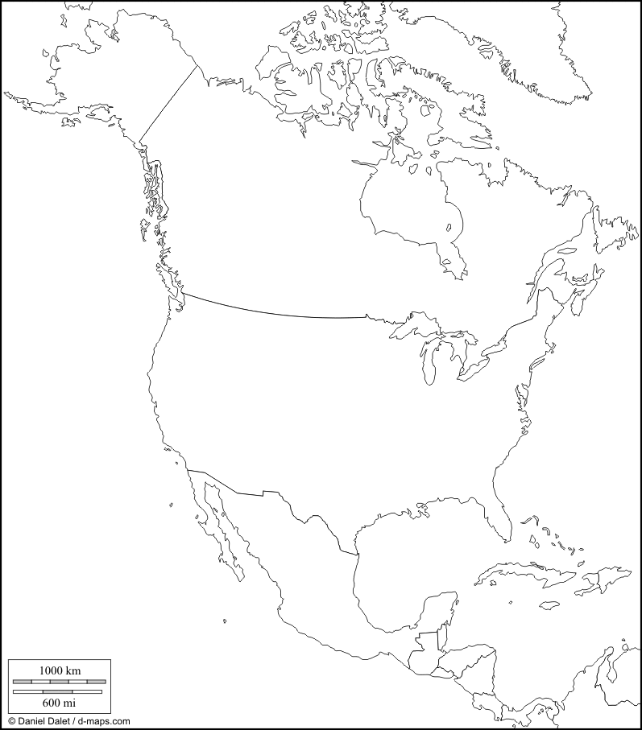
Put a star to identify where
the capital is located.

