Know and Be Able to Ch. 13 Urban Development
KNOW: You should be able to define all these terms and give examples for each. Bolded terms also show up in APES.

Annexation
Barrio
Bid-Rent Curve
Bochert’s Epochs of Urban Evolution
Central Business District (CBD)
Central City
Central Place Theory
City
Concentric Zone Model (Burgess)
Conurbation
Density Gradient
Economic Base
Edge City
European City Model
Favela
Gentrification
Greenbelts
Harris, Chauncey
Hinterland
Islamic City Model
Latin American City Model (Griffin-Ford)
London
Louis Wirth Characteristics Of Settlements (pg. 454)
Market Area
Megacity
Megalopolis
Metropolitan Area
Mexico City
Multiple Nuclei Model (Harris-Ullman)
New York City
New Urbanism
Peripheral Model (Harris)
Primate City Rule
Public Housing
Range
Rank-Size Rule (Zipf’s Law)
Redlining
Sector Model (Hoyt)
Settlement
Smart Growth
Socio-Economic Status
Southeast Asian City Model
Sprawl
Squatter Settlement
Sub-Saharan Africa City Model
Suburb
Threshold
Town
Tokyo
Underclass
Urban Realms Model (Vance)
Urban Renewal
Urban Primacy
World City
Zone In Transition
Zoning

BE ABLE TO: Read through these objectives before the test, if you know with confidence you can fully explain and meet each of these objectives, then you are ready for the test.
- Explain the factors that initiate and drive urbanization and suburbanization.
- Apply models to explain the hierarchy and interaction patterns of urban settlements.
- Explain the models of internal city structure and urban development.
- Analyze residential land use in terms of low-, medium-, and high-density housing.
- Evaluate the infrastructure of cities.
- Explain the planning and design issues and political organization of urban areas.
- Analyze the demographic composition and population characteristics of cities using quantitative and qualitative data.
- Evaluate problems and solutions associated with growth and decline within urban areas.
- Evaluate problems associated with urban sustainability.

Chapter 13 Reading Questions

- Describe the 3 types of services found in a CBD: Public services, Business services, Consumer services
- Briefly explain why certain activities are excluded or hard to find in in then CBD :
- Define food desert & why are they typically found in lower income areas of a CBD?
- Define census tracts & social area analysis
- How do these models help geographers explain where different types of people live in a city?
- Identify three differences between the layout of U.S. cities and European cities:
- What is a squatter settlement and where are they located and why do they develop?
- Describe Larry Ford & Ernest Griffin’s Latin American model (fig,. 13-18)
- List three characteristics of pre-colonial cities in LDCs:
- Point out three ways these cities changed once Europeans took over:
- Point out three changes these cities have undergone since their independence:
- Describe Harris’s peripheral model:
- What is an urban area?
- What is a metropolitan statistical area (MSA) and a consolidated metropolitan statistical area (CMSA)?
- What is annexation and how has the attitude toward it changed in recent times?
- What is the density gradient and how is it used to study urban areas?
- Define Sprawl& how does it characterize suburbs?
- What is smart growth and give an example of where it is being used?
- Discuss the two ways the modern residential suburb is segregated:
- Discuss how the following have contributed to the growth of suburbs: Motor vehicles, public transportation
- Point out two differences between public transportation in the U.S. and in Europe:
- Why is public transportation a mixed blessing?
- Give three reasons why many central cities have witnessed population decline since 1950?
- What is “local government fragmentation” and what problems are caused by it?
- Why is the rapid growth of cities in LDCs surprising?
- List and explain the three characteristics Louis Wirth used to define a city: (pg. 454)
- List and explain three physical definitions of urban settlements:
- Explain how the following add to the deterioration of cities: Filtering, Redlining
- Explain three problems faced by low income inner city residents:
- Our text states “Inner-city residents are trapped as permanent underclass because they live in a culture of poverty.” Explain.

Mapping Skills Language Distribution

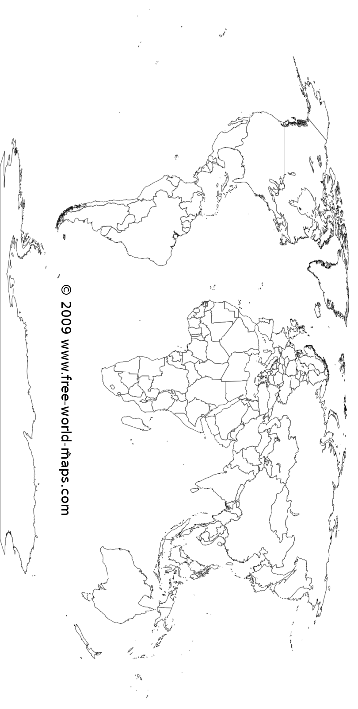
On the quiz you will be asked to locate 25 countries based on the majority language of its population. I will ask you about English, Spanish, and Arabic for 15 of the countries. The other 10 must be other languages and countries you identify on your own.

